**FINAL EXAMINATION** 

| TERM | COURSE NAME | COURSE CODE | VERSION |
| --- | --- | --- | --- |
| **Summer** | Human-Computer Interaction | BTH745 | A |

| Name | Khai Phan Thanh |
| --- | --- |
| Student Number | 100901164 |
| Section | NAA |

DATE: August 13, 2020

TIME ALLOWED: 2 periods

PERCENTAGE: 30%

TOTAL MARKS: 90 marks

PROFESSOR(S): Allan Randall, Tatiana Outkina

SPECIAL INSTRUCTIONS:

1. Open books.
2. Write your answers in the MS Word electronic format. Expand the space between the questions accordingly.
3. Name your submission document and upload to BB in accordance to the instruction provided at the end of this document.
4. Use calculators.

This exam includes a *cover page*, plus __8 __ (eight) pages of questions.

|  |
| --- |
| SENECA’S ACADEMIC INTEGRITY POLICY |
| As a Seneca student, you must conduct yourself in an honest and trustworthy manner in all aspects of your academic career. A dishonest attempt to obtain an academic advantage is considered an offense, and will not be tolerated by the College. |

APPROVED BY:

Kathy Dumanski, Chair, School of SDDS

**Part 1. Short Answer Questions – 40 marks (5 marks for each item)**Do 8 *out of the 10* questions ONLY.

1. **Briefly explain the value of open and closed questions in data gathering**

* Close question limit the answer to such as True/False or Yes/No, or those have pre-made answer, known as predetermined format
* Open question allow user or tester to freely type in what they have in mind, do not have predetermined format

1. **Briefly explain the difference between UI usability and user experience (UX) goals.**

* UI usability is the asset that user going to interact with, or known as the main layout on the screen. The goal of UI is to keep it as simple as possible however, still provide users enough functionality that they need
* UX is the interaction and experience user have from the UI. Basically, UX is know as the back-end of the prototype and control how things should work accordingly for that specific function.

1. **Briefly explain some of the goals of early (low-fidelity) prototype evaluation.**

* Low-fidelity prototypes are sketching step with all of the ideas and design layout.
* It mostly contain the UI with all of the approach for that design.
* It can have multiple prototype and have user test each of them before choosing one and make it high-fidelity model.

1. **List and briefly explain the various stages of user-centred iterative UI prototype development.**

* **Early Focus on user and tasks**: study the behaviour characteristics of the user, understand their general and common needs to successfully design a compatible one to them
* **Empirical measurement**: understand user’s reaction and performance to the prototype or specific task in the prototype. Such testing should be observed, recorded and analysed afterward to determine the usability of that specific function.
* **Iterative Design**: enhance the prototype or program if there is seems to be a problem when user using it. Testing is strongly suggest to collect user behaviour before rolling out the product to market

1. **Briefly explain some of the goals of late (high-fidelity) prototype evaluation.**

* High-fidelity prototype at this point should be an almost complete prototype, where most of the functionality has been decided and placed correctly so user can comfortably use it.
* It should have most of the layout done and ready for user to be testing, interact and use.
* It should be done on a computer-based and recommend to be on a software.

1. **Name at least 2 methods of prototype evaluation. For each method, indicate the kind of situation where it would be most effective.**

* **Interaction**: observe how long it takes a user to interact a same task in 2 different model. If a model requires more time to complete an interaction, it should be evaluate to understand why does it take user a longer time. Situation could be to try a specfic task for a Programming Software and see which one make user spend more time to compile a program.
* **Design Approach**: evaluate whether the prototype is comply with the approach designed for the prototypes, or in another way, does this prototype included the majority component the team and user has decided for the program or not. It is ok to miss 1 or 2 functionality but they must be a non-crucial one as it will has a low-impact to the program. Situation could be to compare between 2 prototype for elimination and consider which one has more or better functionality to keep.

1. **What are some examples of bias in data collection and/or analysis?**

* Avoid bias such as sterotype about something, like Gender, Person’s nationality behaviour (people from that country must do this or that,…), take result of the surveyer’s favourite person and use that as a general answer for everyone,…
* When collection data or doing analysis, it is always required to avoid as much bias as possible as it will affect how the result going to be.

1. **State the difference between natural and learned CD relationships using an example.**

* Natural CD is measure when user is using the interaction for the first time and has no knowledge about it. Usually, Natural CD will take more time to get used to the program.
* Learned CD is measure when user is already have at least some interaction to the program and know the behaviour of it. Learned CD will usually take less time to complete the action.

1. State the main idea of Fitts’ Law. Name at least one specific evaluation metric where it might be useful to apply it.
2. Briefly explain the relationship between CD gain and positioning time. Include both gross-positioning and fine-positioning times into your consideration.

**Part 3 Long Answer Questions & Problems – (50 marks)**

Do *5 out of the 6* questions ONLY.

1. **Error rate – 10 marks**
   1. **In your own words, explain the nature of this metric. Include samples of user errors when attempting to complete typical UI task.**
   * Error rate is the frequency of error a user can make in a number of time. It is calculate as chance of making error per minute.
   1. **You are running usability testing event, and you have 5 users. All of them make errors when working on the task. The time of the task is limited to 1 hour. Following is the data collected on the number of errors made:**

|  |  |  |
| --- | --- | --- |
| Subject ID | Completion time (*min*) | Errors made |
| 1 | 20 | 9 |
| 2 | 60 | 7 |
| 3 | 30 | 10 |
| 4 | 44 | 18 |
| 5 | 12 | 1 |

Create a reasonable and useful metric based on the information provided and perform the calculation. Show your work.

1. Subject ID #1: 9/20 = 0.15 or ~45%
2. Subject ID #2: 7/60 = 0.11(6) or ~11.6(6)%
3. Subject ID #3: 10/30 = 0.16(6) or ~33.3(3)%
4. Subject ID #4: 18/44 = 0.40(90) or ~40.(90)%
5. Subject ID #5: 1/12 = 0.83(3) or ~8.33(3)%

*The number in the bracket represent for the infinity continous repeat of that number, according to mathematical symbol

1. **Lostness – 10 marks**
   1. **In your own words explain the nature of this metric.**
   * Lostness is know as the calculation to determine how lost the user are with a specific task in prototype or it could be for an entire prototype. The higher the number, the “more loss” user are.
   1. **You are signing up for a subscription web service. To complete the task, you visit 12 different pages (18 pages including repeat visits). If the minimum number of pages that must be visited is 5, how lost are you? Show your work.**

N (# of different screen visited): 12

S (total screen visited): 18

R (minimum page required): 5

* Therefore, we have. SQRT(((12/18)-1)^2 + ((5/12)-1)^2) is equal: 0.6718 or ~0.672

1. **Time-based Efficiency (Task Completion Time) – 10 marks**
   1. **In your own words explain the nature and importance of this metric.**
   * This metrics is use to calculate the user interaction for the prototype or for a specific task. It takes an account of completion status (completed or not), with the time to determine how the user did on the prototype.
   1. You are running usability testing event, and you have 5 users. All of them are required to complete the same task. 3 users completed the task successfully, and it takes to them just 2 seconds. Another one completed the task successfully in 3 seconds, but another one made 3 attempts with no success, and finally gave up. Create a reasonable and useful time-efficiency metric based on the information given and perform the calculation. Show your work.
   * Assume that 4 person is complete with the task and 1 person who made 3 attempts, is also count as 3 person didn’t complete the task, therefore we have.

|  |  |
| --- | --- |
| Successful? | Time taken |
| 1 | 2 |
| 1 | 2 |
| 1 | 2 |
| 1 | 3 |
| 0 | 5 |
| 0 | 5 |
| 0 | 5 |

* From that, we know the completion rate is 4/7 which is about 57%

According from the fomular below, we have:



* N (total number of tasks) : 1
* R (total number of user): 7
* User 1: Completion (1) and Time (2)
* User 2: Completion (1) and Time (2)
* User 3: Completion (1) and Time (2)
* User 4: Completion (1) and Time (3)
* User 5: Completion (0) and Time (6)
* User 6: Completion (0) and Time (6)
* User 7: Completion (0) and Time (6)

From that, we have

(½+ ½ + ½ + 1/3 + 0/5 + 0/5 + 0/5) + (1*7) which give us 0.262 task goal / sec

1. CD Relationships – 10 marks

Given the following UI control-display diagram, complete the relationship chart. Explain which relationships (if any) are natural and which (if any) are learned, and why.

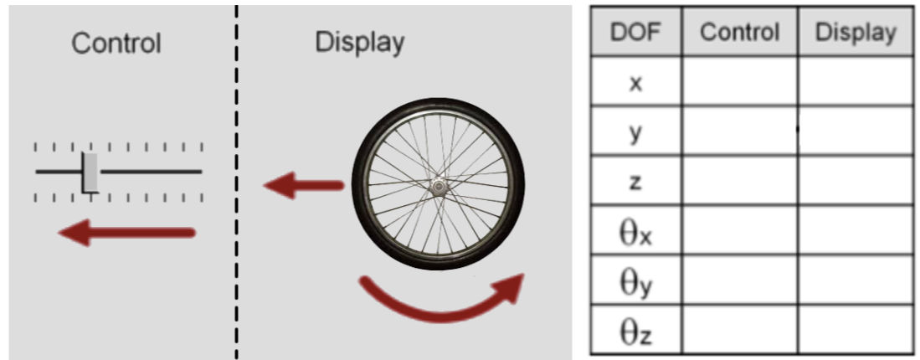

1. **Fitts’ Law – 10 marks**

**If it takes a particular user 1.2 seconds to move the hand cursor and click the OK button in scenario (a) below, how long will it take the subject to do the same thing in scenario (b)? Assume it always takes a minimum of one quarter of a second in this situation to do anything at all, no matter how close the cursor is to the button. Show your work.**

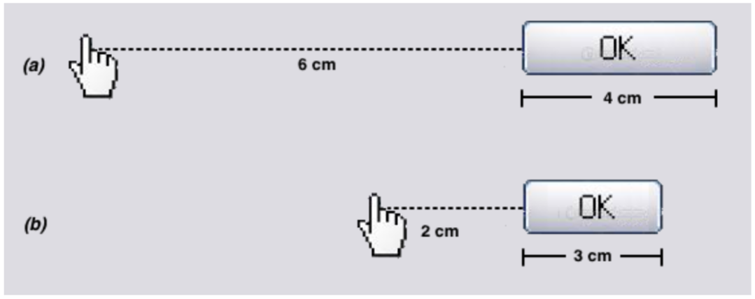

Time for (a) = 1.2 seconds.

Time for (b) = 1.286s.

According to Fitt’s Law, we have

Ot is 1.2s

G is 0.25

1. **HCI Model – 10 marks**

**Fully explain the cognitive HCI model studied in class, using an example relevant to HCI. You must include at least one fully labelled diagram, and indicate how the features of the model might affect the design of a user interface.**

* The cognitive HCI is how a user as a human-being see a UI and know how to interact with that. It is taking an assumption that this button will do this and this button will do that. Therefore, before designing any UI that strongly depend on cognitive, we have to taken account of a few things, such as task knowledge and task environment.

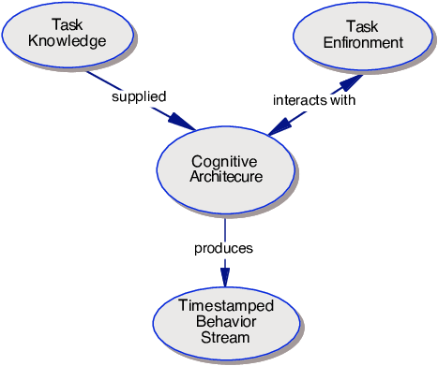

* Above is a simple diagram of how to design a cognitive approach for prototype. We have to taken account of task knowledge, such as when user see that button, do they know right away what that button will do (ex. An emoji button will give user a knowledge of this button will create some smiley face or icon). Other things to consider is that is that button going to be understand correctly in that environment, as some button could have 2 meaning (ex. Camera button on desktop can sometimes mean to take a photo but in different environment can mean to insert a photo). From that, we will decide how can developer design the prototype to eliminate the confusion for user and have it test before rolling out.